Table of Contents
1 Adapter Pattern 1
1.1 Class Adapters - Based on (Multiple) Inheritance 1
1.2 Object Adapters 1

Adapter Pattern
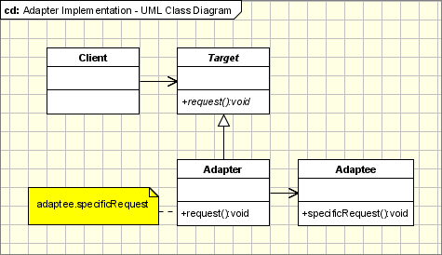

Class Adapters - Based on (Multiple) Inheritance
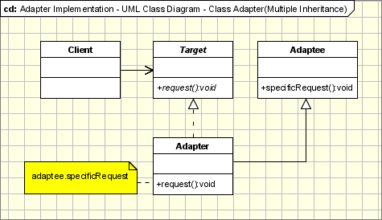

Object Adapters

